Railway Reservation
Software Requirement Specification
Document ID: 0000.doc
Author: JAIKANTH S
Version: 0.1
Date: June 11, 2024

1. Objective and Scope 3
2. Project End Users 3
3. Features 3
3.1 Login to the system 3
3.2 Train Search and Booking 4
3.3 Ticket Management 4
3.4 Payment Integration 4
3.5 Train Schedule Management 4
3.6 Seat Allocation and Reservation 4
3.7 Tickets
5

Objective and Scope
The objective and the scope of the project is to build a Railway Reservation System that is capable of simplifying the process of booking train tickets and improving overall customer satisfaction.
The scope of the product includes the following basic features:
- The passengers can search for train schedules, check seat availability, and book tickets.
- The system aims to automate ticketing processes, seat allocation, and payment transactions.
- Generate tickets.

Project End Users
Passenger who looking to book train ticket for travel and Administrators who is responsible for managing system operations like adding/editing trains schedules.

Features

Login to the system
Users should be able to register and log in securely to the system.
Validations for Username and Password.
Username: It accepts only Alphabets, Numbers, Dot (.) symbol and Underscore (_) symbol.
Password: It can be anything of the users’ choice.

Train Search and Booking
Passengers should be able to search for trains based on criteria such as origin, destination, date, and class.
The system should display available trains along with their schedules, seat availability, and ticket fares.
Passengers should be able to select seats and book tickets for their preferred journey.

Ticket Management
Users should be able to view and manage their booked tickets, including canceling or modifying reservations.

Payment Integration
Integration with payment gateways to facilitate secure online transactions for ticket booking.
Support for multiple payment methods such as credit/debit cards, net banking, and UPI.

Train Schedule Management
Administrators should be able to add, edit, or remove train schedules.
The system should maintain accurate and up-to-date information regarding train routes, timings, and stops.

Seat Allocation and Reservation
Automatic seat allocation based on passenger preferences and availability.
Support for reserving seats for passengers with special requirements such as senior citizens or individuals with disabilities.

Tickets
This system has Ticket generating capabilities. It shows the train name, departure date and time, passenger details, class type, seating number and payment details. 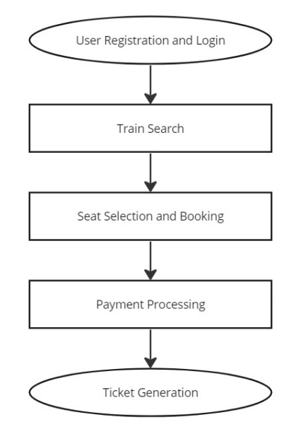
fig:1 flow Diagram
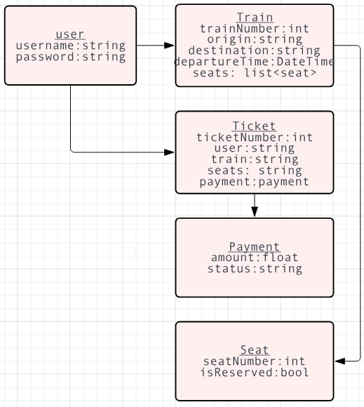
fig:2 class diagram

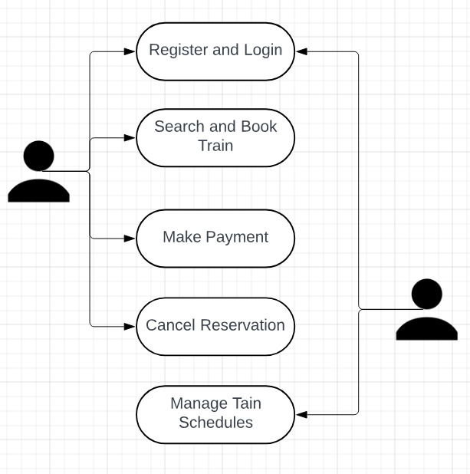
fig:3 use case diagram

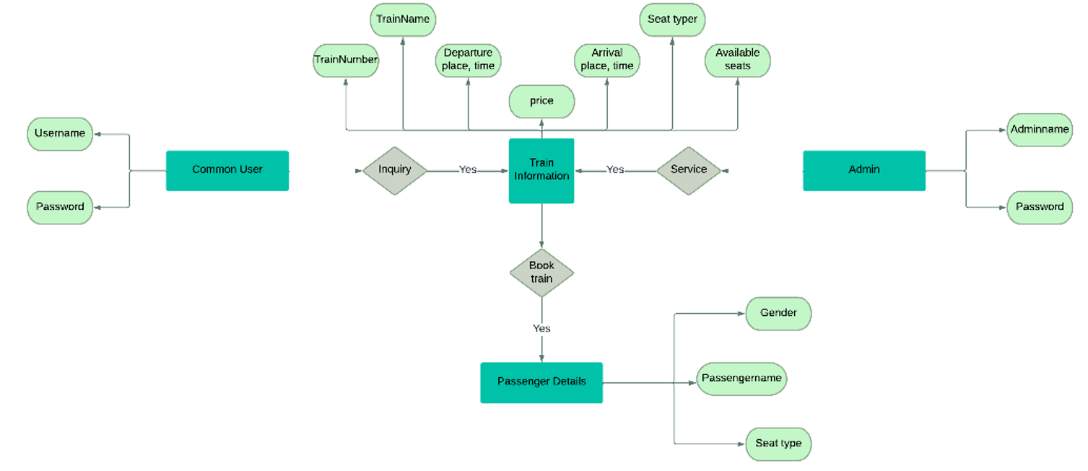
fig:4 ER diagram
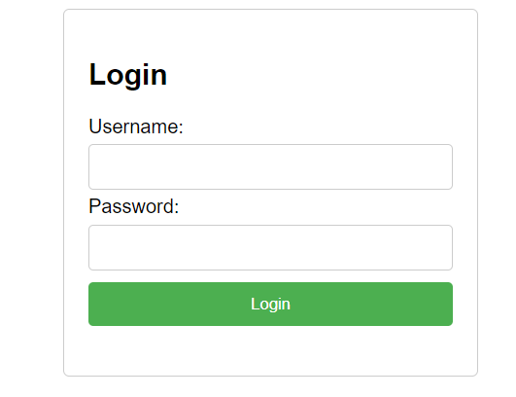
Fig:5 login page

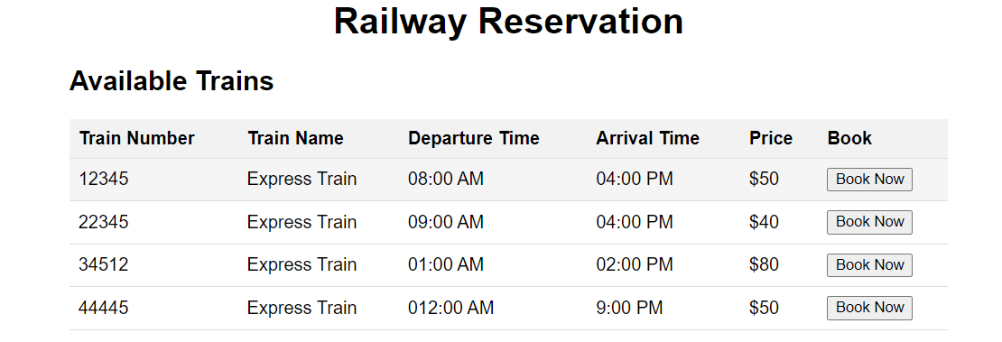
Fig:6 train details

